**QUICKKART – THE E-COMMERCE APPLICATION**

**TASK: 1** - Local Environment Setup & Test

**---------------------------------------------------------------------------------------------------------**

**-Quickkart** is an *E-Commerce Web Application*.

Users can buy products and commodities using this web app.

**Business Requirement:**

This web app needs to be fully architected in Azure Cloud.

**Technology Stack:**

**Front-End:** Angular 13

**Backend**: Dotnet core 3.1

**DB**: Azure SQL Server.

**Blob Store**: Azure Storage Account.

**TASK-1:**

**Agenda:**

* Set up the Local environment
* Test the code locally first.

1. Download **Visual Studio Community 2022** & install it with Azure **Development SDK** **(**[Download Visual Studio Tools - Install Free for Windows, Mac, Linux (microsoft.com)](https://visualstudio.microsoft.com/downloads/) **)**

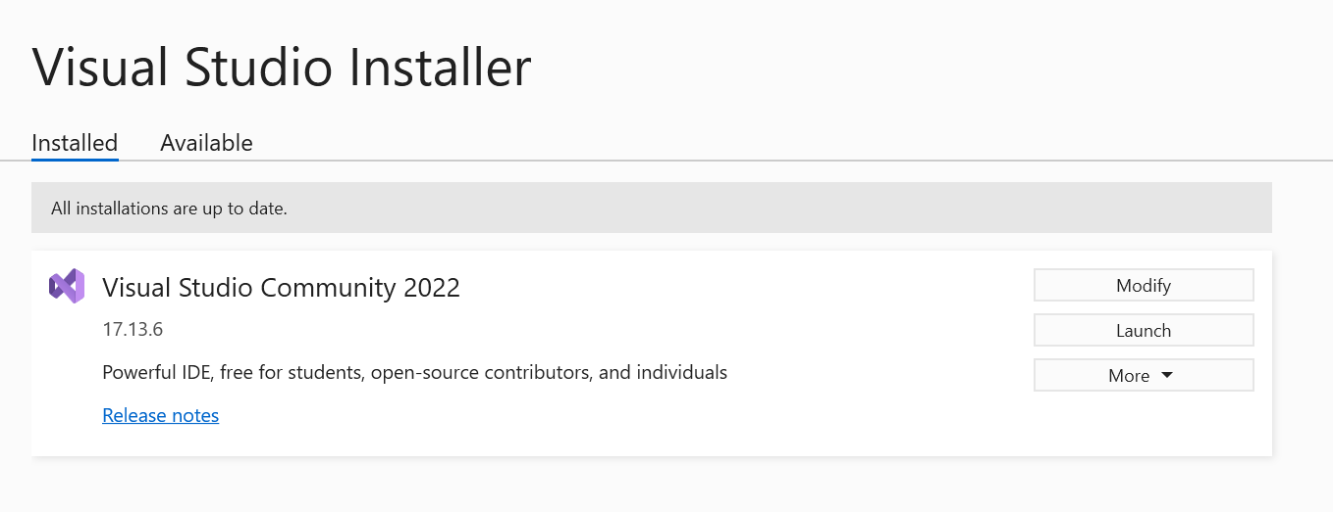

1. **Install .Net core 3.1 (**[Download .NET Core 3.1 (Linux, macOS, and Windows) (microsoft.com)](https://dotnet.microsoft.com/en-us/download/dotnet/3.1)**)**

Once download and installation is done then open Visual Studio and check as follows:

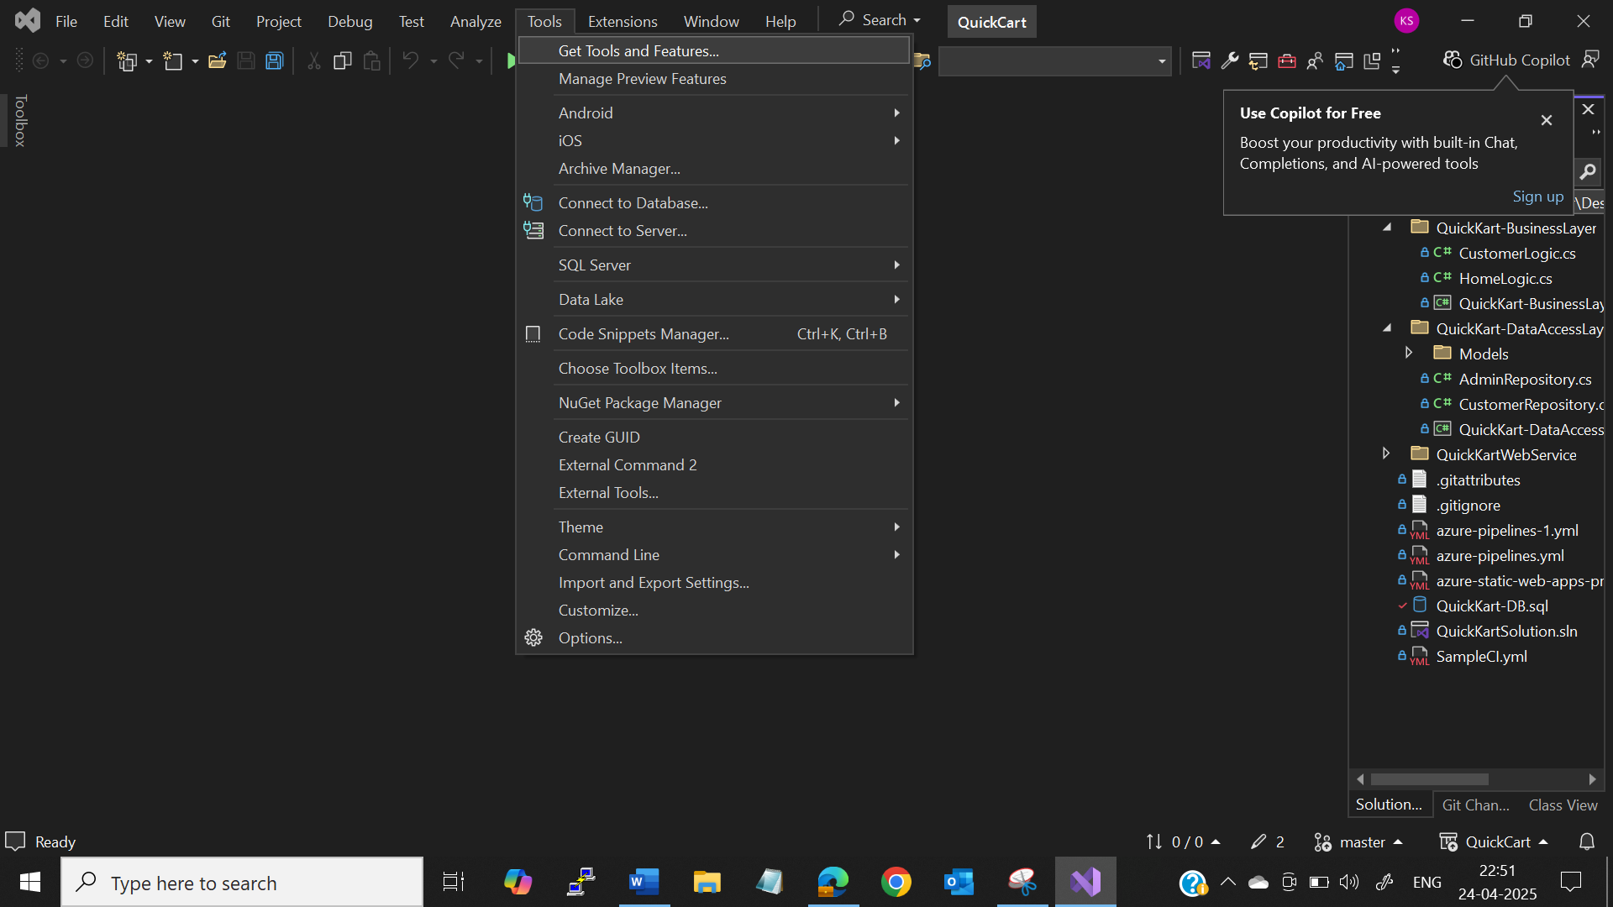

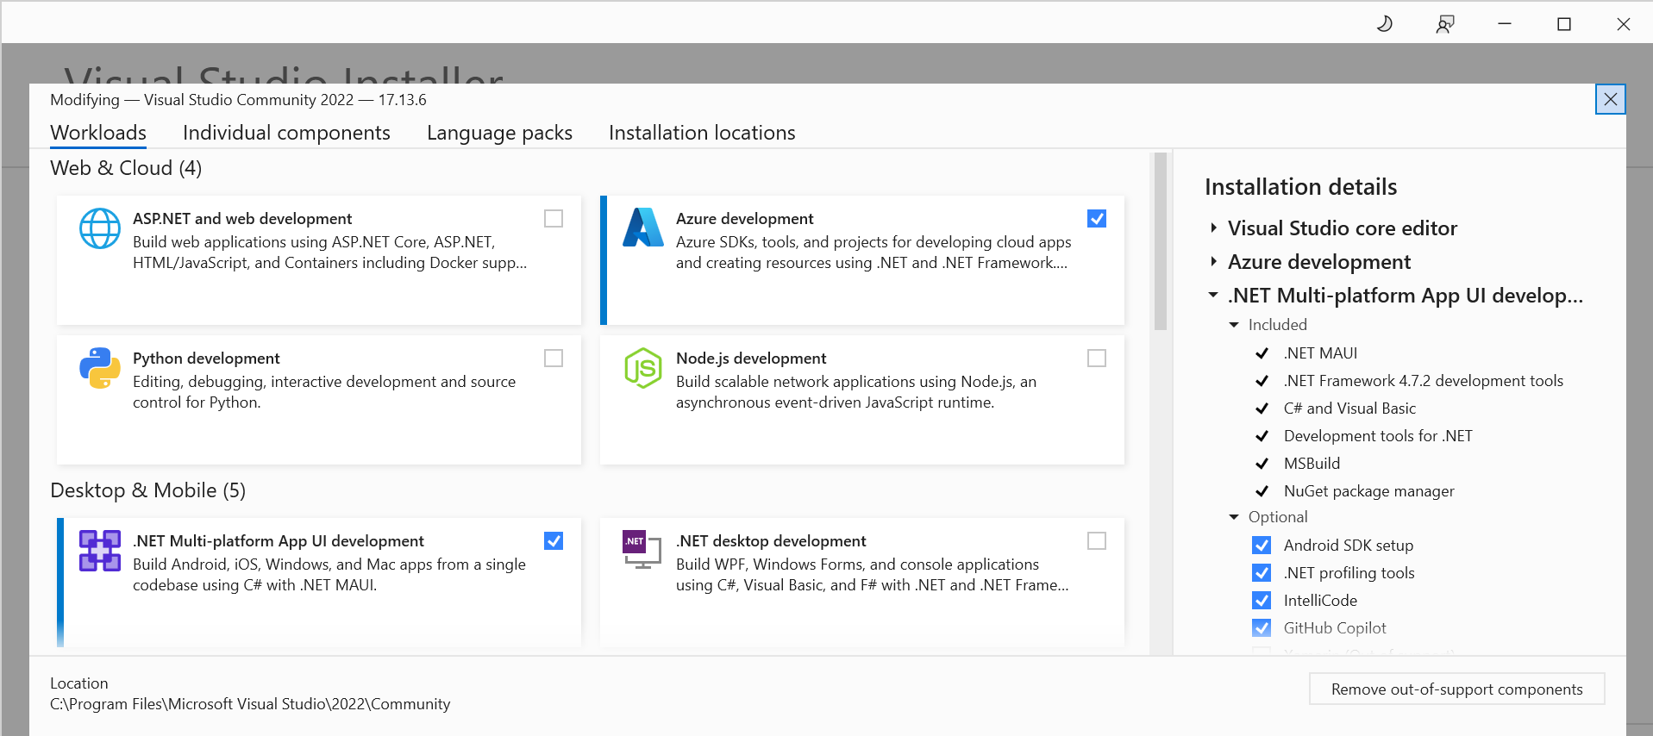

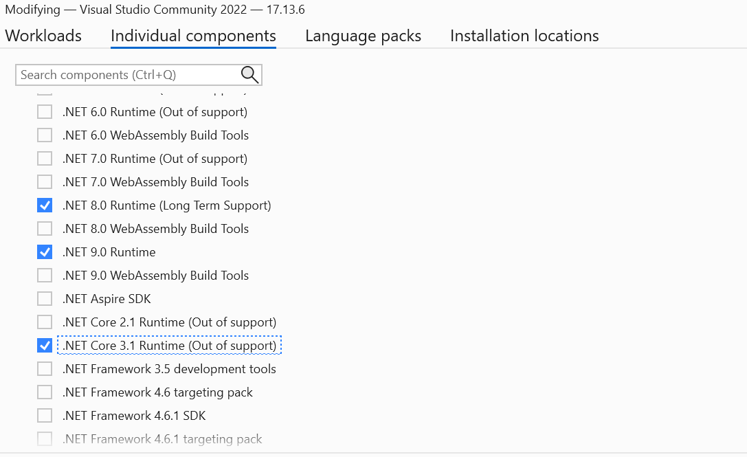

* Once done go to Visual Studio 2022 -> Tools ->  Nuget Package manager -> Package manager setting -> package sources -> Add the package source

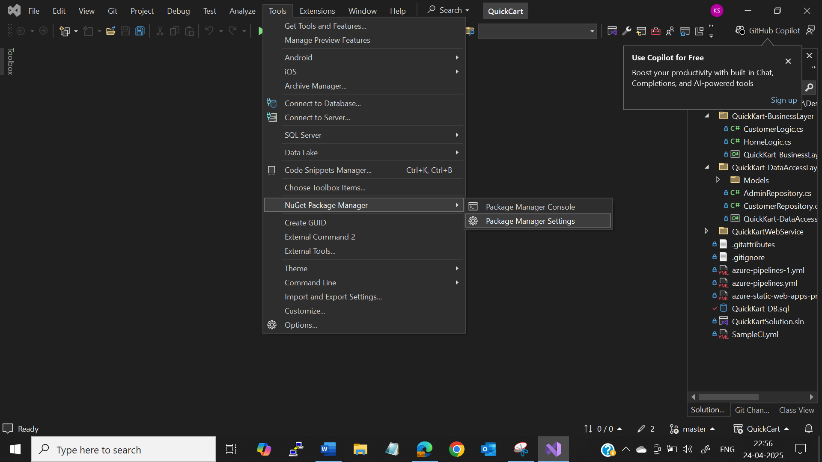

* Name : nuget.org
* Source: <https://api.nuget.org/v3/index.json>

Select only this package. If you have any other package sources deselect it.

1. Download **VS Code** from [Download Visual Studio Code - Mac, Linux, Windows](https://code.visualstudio.com/download)

1. install Git from [Git - Downloads (git-scm.com)](https://git-scm.com/downloads)

Check the version by **git -v**

1. Clone the **backend Project in your local system through either VS code**

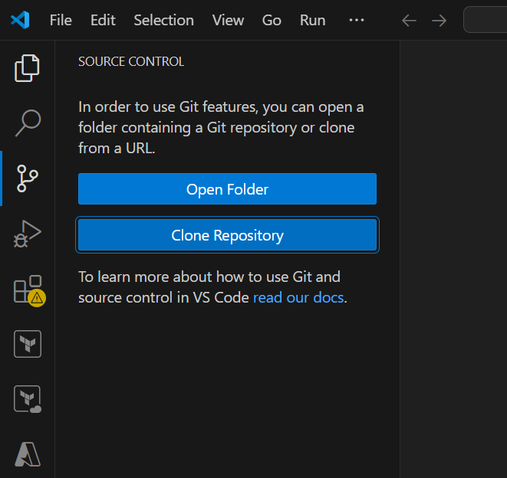

Create a folder called QuickKart – This will hold all the code.

**Backend Clone URL**: <https://CTJGP-B35@dev.azure.com/CTJGP-B35/Batch35%20-%20Komal/_git/QuickCart%20Backend>

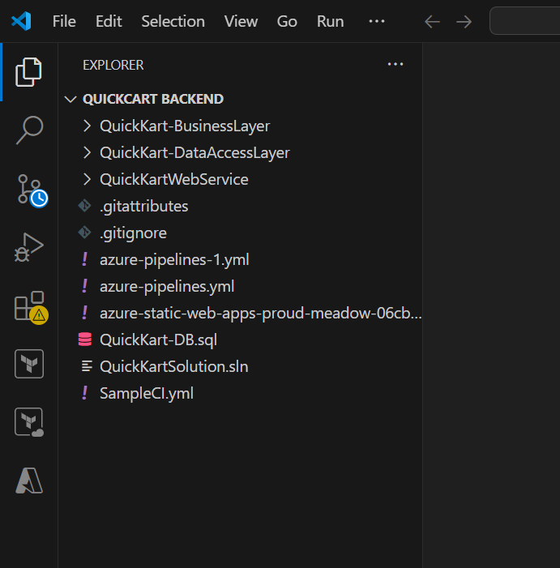

1. Clone the frontend **Project in your local system through either VS code or Visual studio**

**Frontend Clone URL:** <https://CTJGP-B35@dev.azure.com/CTJGP-B35/Batch35%20-%20Komal/_git/Quick-Cart-FrontEnd>

1. Install **Node.js** from [Download | Node.js (nodejs.org)](https://nodejs.org/en/download/)

 Node.js 16

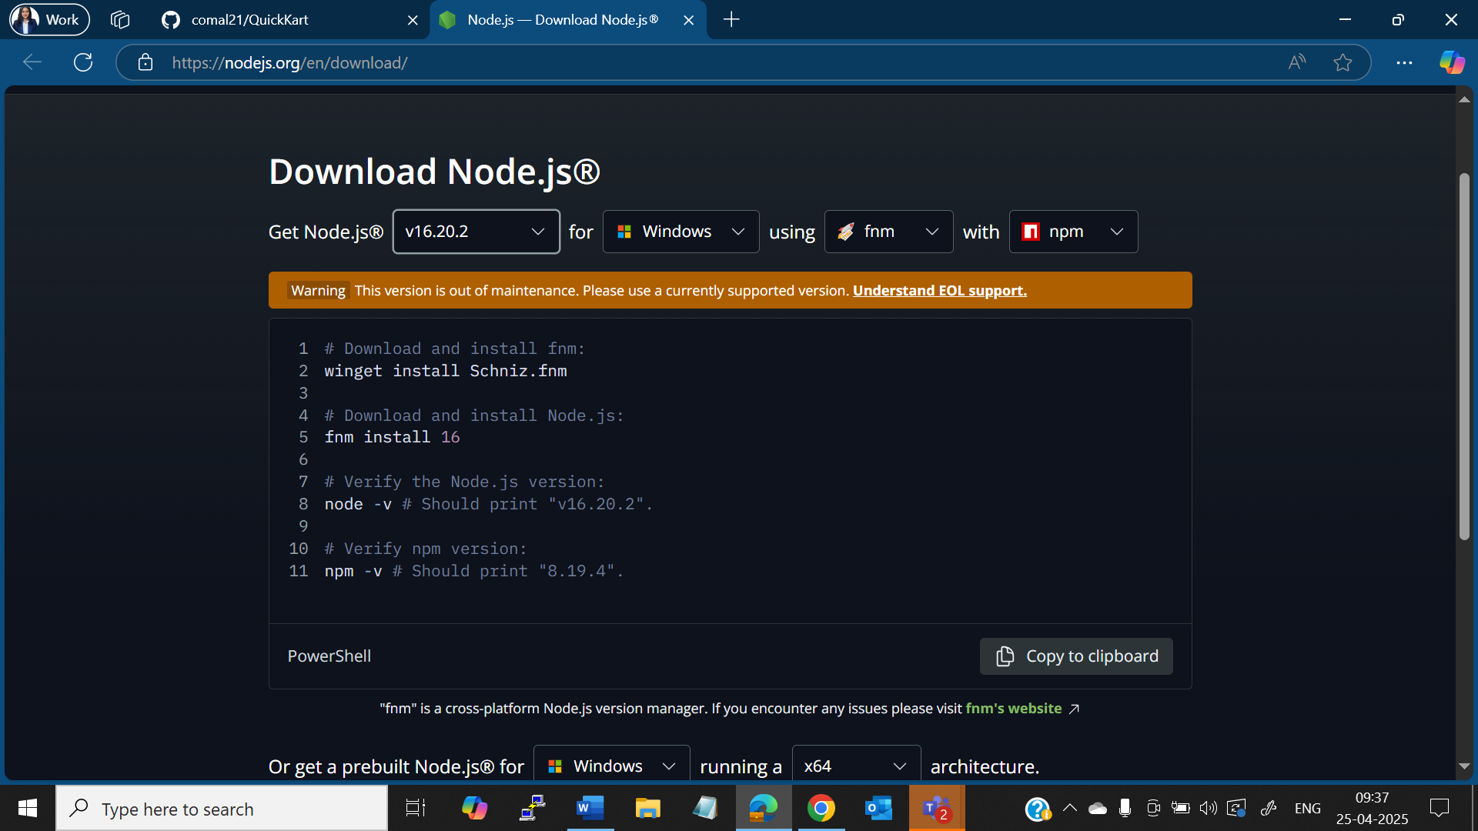

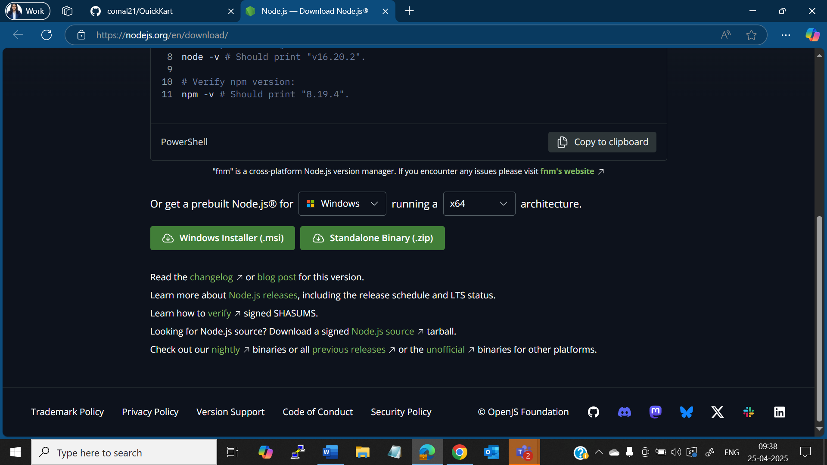

node -v

# Should output: v16.20.2

npm -v

# Should output the corresponding npm version

1. Install **angular CLI** by the below command **(Install it in quickkart frontend) (Go to quickkart folder -> quickkart-frontend-> open cmd-> run above command)**

**npm install -g @angular/cli@13.3.9**

**(If there is error while using previous version then you can use )         [npm install -g @angular/cli@latest ]**

If you want to uninstall due to some issue or Angular js is not working properly [ npm uninstall -g @angular/cli  ]

1. Check if the version is installed by **ng v**

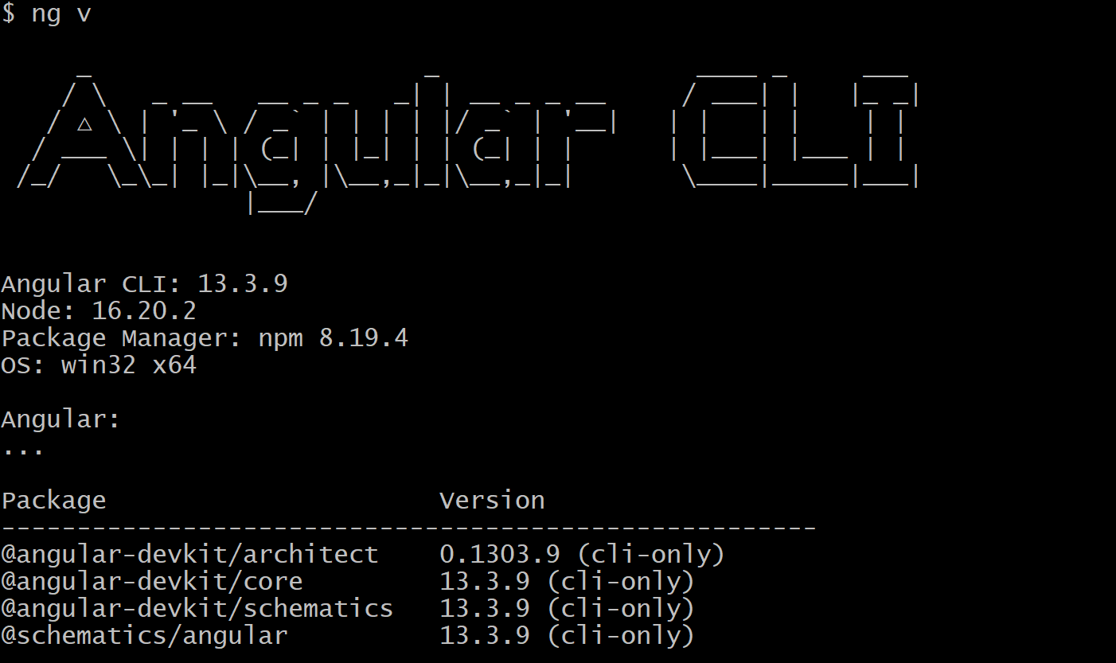

If there are any errors in the version column then try below command:

 npm audit fix --force

 Go to the folder which contains the backend code

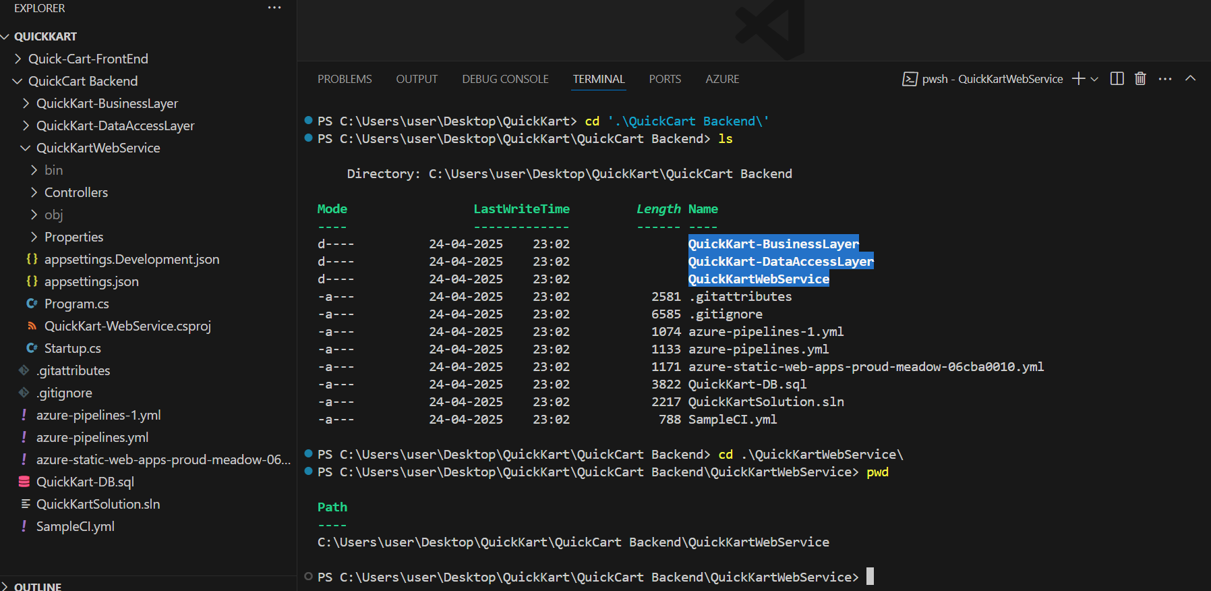

 Run **dotnet run**

* Once it run at the last it will give you URL like below

* [https://localhost:5001](https://localhost:5001/)
* [**https://localhost:5001/api/home/getproducts**](https://localhost:5001/api/home/getproducts)
* This will give you Json data.

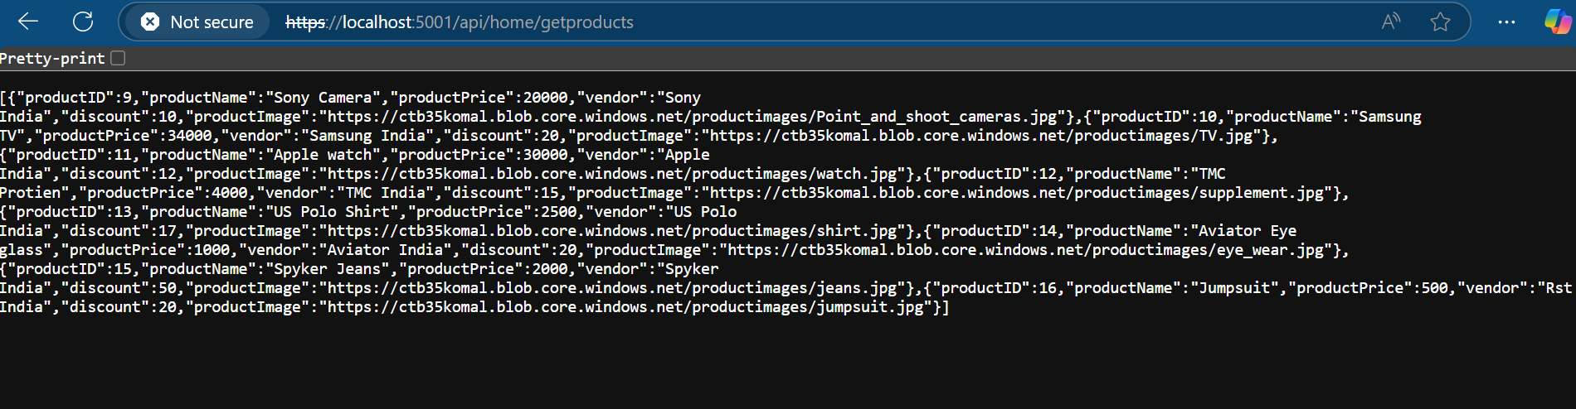

If this gives error on port no. then go to QuickKartWebService-----Properties-----LaunchSettings.json---- change the port no.

"QuickKartWebService": {

  "commandName": "Project",

  "launchBrowser": true,

  "launchUrl": "weatherforecast",

  "applicationUrl": "https://localhost:5002;http://localhost:5003",

  "environmentVariables": {

    "ASPNETCORE_ENVIRONMENT": "Development"

* Go to the directory where you have cloned the front-end -> Open new command prompt.

Execute the below command.

**npm install**

This will create the **Node_Modules**.

* If there is still the error use following command
* ng update @angular/core@15 @angular/cli@15

1. Start the application by running below command
2. **ng serve -o**

* It will redirect to browser you need to add as below

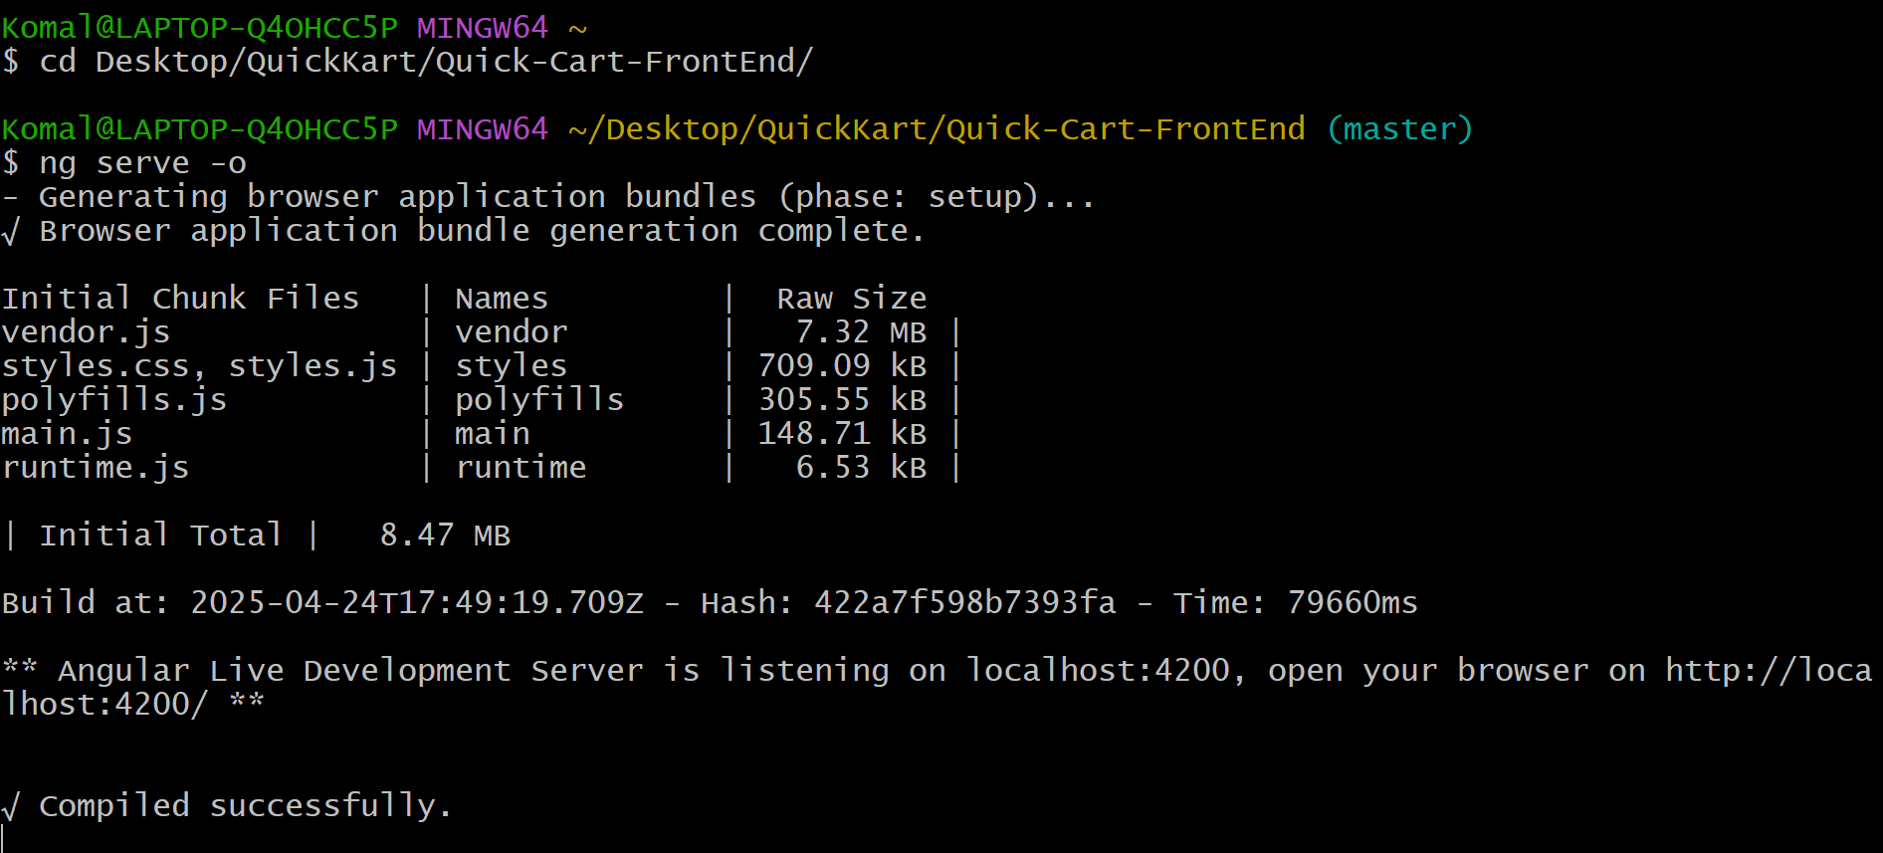

* https://localhost:4200/api/home/getproducts

**output should be as below**

